SQL Server Integration Services

# Module 03 – Lab 02: Project PARAMETER

1. This lab continues from where previous lab left off.

We will be creating a new FTP connection that is only for Package1.dtsx (2nd package), we do not want to create shared connection because only one package in the project will ever use this FTP connection. We do not want to hard code the connection string, so will we will create a parameter for the FTP connection.

1. Open Package1.dtsx by double-clicking in Solution Explore.
2. Set up a connection manager to our FTP site. In the bottom center pain under Connection Manger, right-click select New Connection.  
   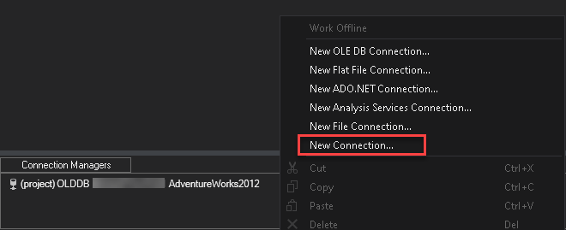
3. In the Add SSIS Connect Manager, select FTP and click on Add.  
   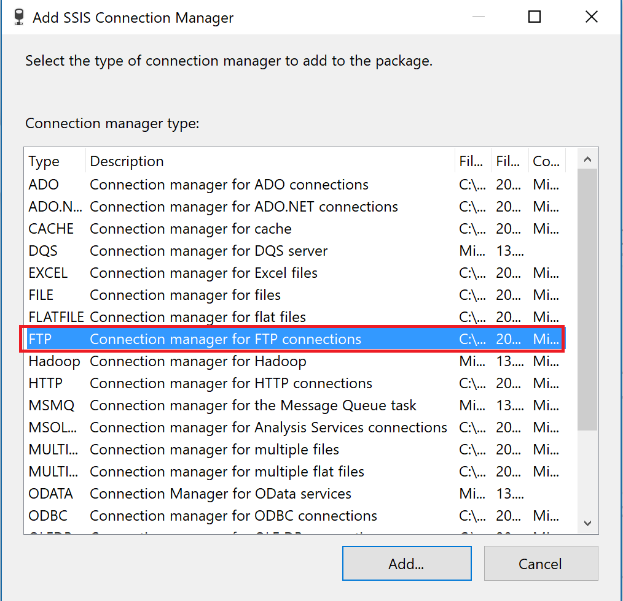
4. In FTP connection manager editor, type the server name “ftp.nluug.nl” and click Test Connection.  
   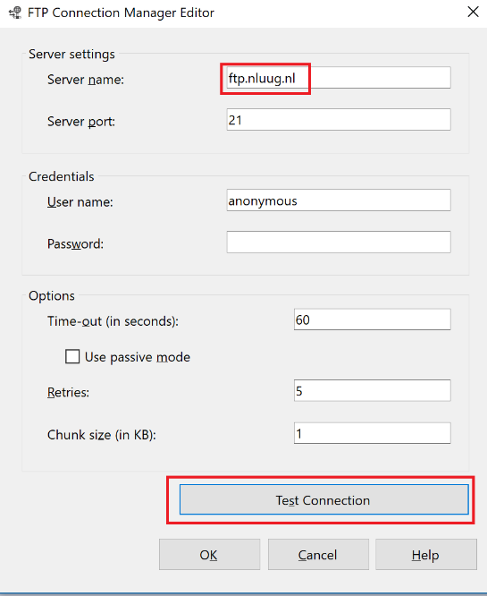

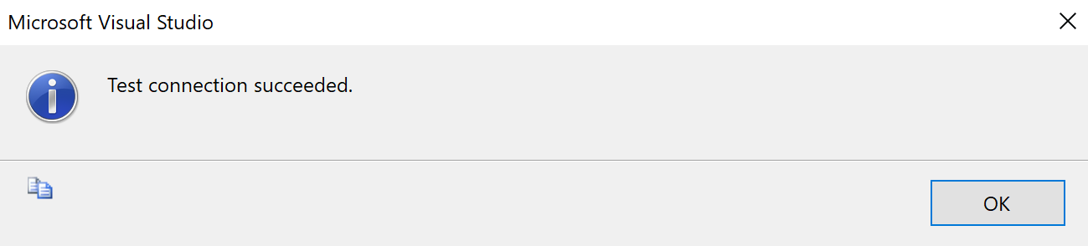

Click OK to close the Test connection dialog.

1. Click OK in Configure FTP Connection Manager editor. A new FTP connection is added under Connection Manager.  
     
   *Hint: Rename the connection manager to* [*FTP.nuluug.nl*](ftp://FTP.nuluug.nl) *to make it easier to remember intention. This will make it easier to identify which driver is being used for the driver.*



1. Right-click on connection FTP.Servername and select Parameterize.

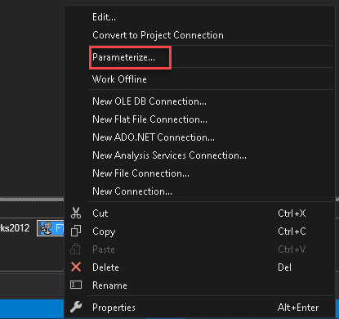

1. Set the following settings in the Parametrize dialog screen

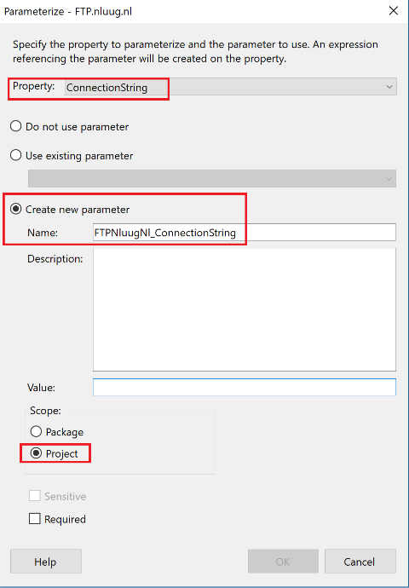

1. Click OK in Parameterize editor. You should *fx* (mathematical function) icon next to the connection Manager. Letting you know visually that at one property expression is set.

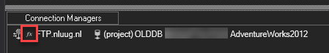

1. Right click the FTP connection and select Properties.

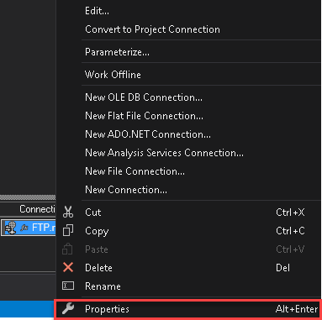

1. In the properties pane, notice the Property Expression exists for the ConnectionString property under Expressions. Which is assigned the $Project parameter value.

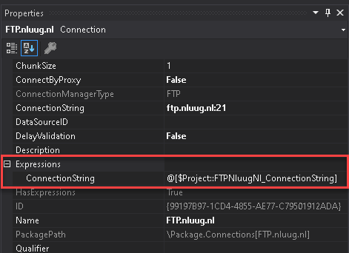

1. Open Parameter value, by **double-clicking** Project.params in the Solution Explorer.

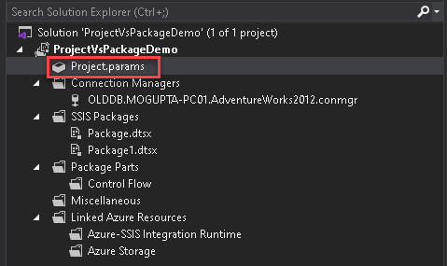

1. Value has been moved to Project Parameters, as shown below.

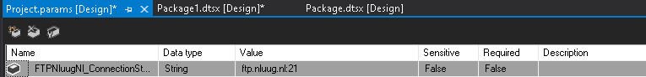

This allows us to deploy the project and update the connection string on demand without having to redeploy the package.